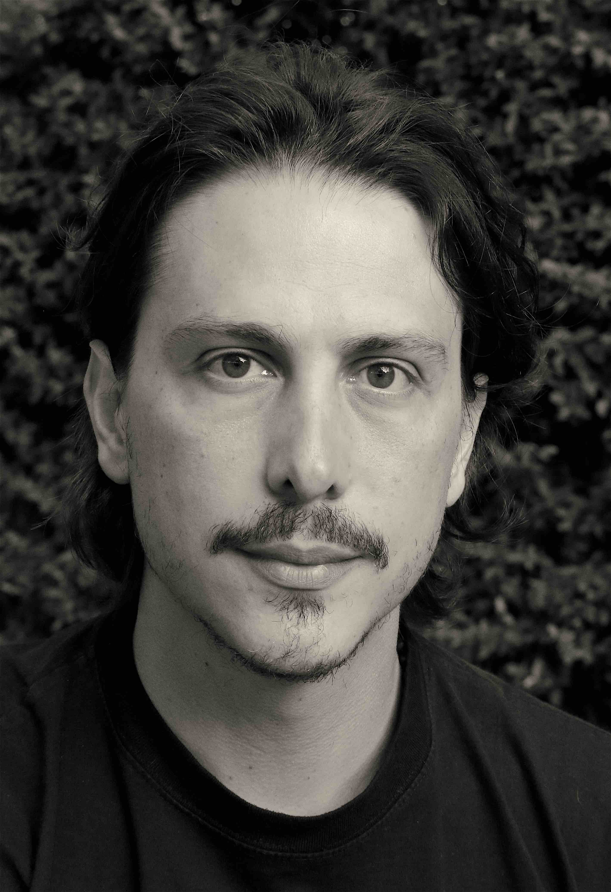
ALVARO FLORES
Ethnics Artiste Agency: info@ethnicsaa.co.uk
Spotlight: 7557-8940-3895 Tel: +44 (0) 208 523 4242
Voice type: High Baritone Eyes: Hazel Height: 6’3”
Range: G1 to A3, Hair: Dark brown

Belt to B3b

Training

-BA (Hons) Acting Italia Conti Academy, London
-LRAM in Musical Theatre Royal Academy of Music, London
-PG Dip Musical Theatre Royal Academy of Music, London
-Physical Theatre – Corporeal Mime Theatre de l’Ange Fou, London
-Acting for Film, Radio and TV NYCDA, New York
Berlinale Talent Campus at the Guadalajara International Film Festival 2010.

Skills
Languages: Spanish (mother tongue), English (fluent), Portuguese (advanced), French (basic).
Dialects: Native Spanish (Mexican, Latin-American, Castillian), RP, Standard American, French, Italian.
Music: Good sightreader. Good piano skills, competent guitarist, ukulele and jarana, vihuela, mandolin.
Movement and Distinction in Armed and Unarmed Combat - (BASSC - elementary)
Dance: UKA 19th and 20th Century Social Dance Award – Honours at Gold Bar
Intermediate Tap dancer, intermediate jazz dancer.

TV/Film

ROLE PRODUCTION LOCATION DIRECTOR
Cartel Man RAMBO 5 Nu Boyana, Bulgaria Adrian Grunberg
Alvaro Daedalus Madrid, Spain Ade Olanrewaju
The Father The Last Bite London Sebastiano Pupino
David Fernandez Air Crash Confidential 3 Shoot Aviation Ltd, UK Chris Roberts
Derleth Las Reglas de la Ruina Mexico Víctor Osuna
The 4th Room London London Sebastiano Pupino
Farinelli Museo Barroco Teatro Fru Fru, Mexico Diego Martínez U.
Doctor Amor de Barrio Televisa, Mexico Francisco Franco
DC Kim Rage London, UK Zahi Farah
Usher The Fall (Cannes 2012) Poole, UK Giles Bartlett
Demi Otra Vida On Location Aric Jackson
Jesus The Car Millbrook Track, UK Sacha Boxell
Dario Rictus Guadalajara, Mexico Victor Osuna

Theatre
ROLE PRODUCTION VENUE DIRECTOR
Freddy Qaddafi’s Cook Actors Centre, London Lynn Lohr
Pedro Tercero The House of the Spirits Cervantes Theatre, London Paula Paz
Cesar Chavez/Soldier The Time of Our Lies Park Theatre, London Che Walker
Gunman #WeAreArrested The Other Place, RSC Sophie Ivatts
Rafael Day of The Living The Other Place, RSC Amy Draper
Miguel de Cervantes Don Quixote in Algiers White Bear, London Franko Figuereido
Novice/Soldier La Expulsión Juan Ruiz, Mexico Luis de Tavira
Cuerda Cuerdas El Galeón, Mexico Richard Viqueira
Punch/Tony Rod Fair Trade Pleasance Theatre Sue Colgrave
Anita LaBeiga WIG OUT Royal Court Theatre Dominic Cooke
Knomo ELEKTRA Camden People’s Theatre Ricky Dukes

Musicals
ROLE PRODUCTION VENUE DIRECTOR
Antonio ClubMex Hope Mill Theatre Julie Atherton
Raul Castro Fidel the Musical Actors Church Tania Azevedo
Melman Madagascar Live International tour Jenn Rapp
Cowboy Crazy For You (48hr) London Palladium Katherine Hare
Glanconer Something Strange Arcola Theatre Helen Tennison
Guido Contini NINE Ye Olde Rose & Crown Ricky Dukes
Josh Duvall Camp Horror Cockpit Theatre Heather Brothers
Cleon Acis y Galatea Wilton’s Music Hall Netia Jones
Anthony Sweeney Todd Shawford Mill Kim Begley
Manny Muñoz City of Angels Jack Lyons Theatre Karen Rabinowitz
Macheath The Beggar’s Opera Landor Theatre Sue Colgrave

Radio, Voice Over, Corporate
ROLE PRODUCTION COMPANY/LOCATION DIRECTOR
The Stranger As Dusk Falls In. Night/Xbox Studios Mark Tan
Carlos Go Go, Cory Carson NetFlix UK John Harley
Audio description La Jauria (The Pack) Series Amazon Prime Video/HBO Sergio Castro
Ezra/ADR Our Girl, BBC Syncorswim, UK Jay Benedict
VO Amazon Echo 5, 8, 10 Amazon Mexico/on-line -
VO Amazon TV Fire Stick Amazon Mexico/on-line -
Presenter Disney Training Disney London, UK Alessandro Attanelli
Lucas In House Capita, London Mi Elfverson
Father (Portuguese) Anti-Smoking Campaing One Life Suffolk Adam Collier

Singing (Concerts)

ROLE PRODUCTION VENUE DIRECTOR
Solo Performer Revolution WAC Arts Che Walker
Ensamble Chess in Concert Royal Albert Hall Hugh Wooldridge
Elton John choir Concert for Diana Wembley Stadium Stephen Hill
Ensamble Acoustic Tuning Event Queen Elizabeth Hall Stephen Hill
Ensamble Fast Fwd -National Theatre The Roundhouse Gareth Valentine/
Nicholas Hytner
Directing and Creative Team
JOB PLAY VENUE DIR/PROD.
Associate Director Time Is Love Finborough Theatre Che Walker
Director Tales of Bedsheets... Cervantes Theatre, London Nic Knight
Director Cootie Shots Kidzania, Mexico Kidzania
Director ErrorisEs, the Musical Rafael Solana, Mexico Virgilio Solorio
Director MAME, the Musical Centro Cultural 1, Mex Ricardo Ortega
Resident Director Godspell, the Musical Teatro Milán, Mex Teatro de Primera
Assistant Director Godspell, the Musical Teatro Milán, Mex Teatro de Primera
Vocal and Mov. Dir. King Kong Palace El Milagro/A Poco No, Mex Rafael Covarrubias
Assistant Director Por Favor, No Mande... Foro Sor Juana, Mex Richard Viqueira
AMD Moll Flanders, Musical London Sue Colgrave

